**Experiment 2.2**

**Student Name:   Gaurav Kumar                                UID: 22MCC20177**

**Branch:   Computer                                                        Section/Group:- 1/B**

**Semester:   One                                                               Date of Performance: 27/11/2022**

**Subject Name:- Design & Analysis of Algorithms Lab                   Subject Code: 22CAP-646**

**Task to be done:**

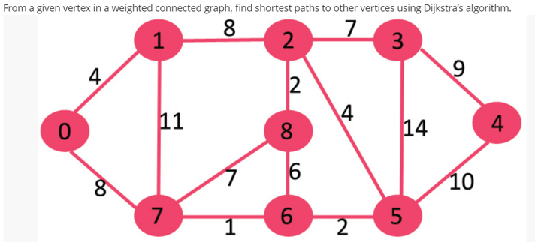

**Steps for experiment/practical:**

**copy and paste your code here/screenshots**

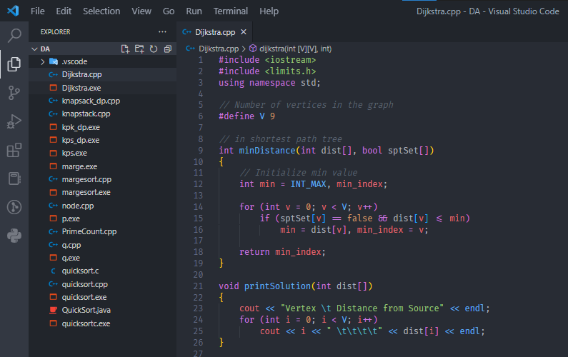

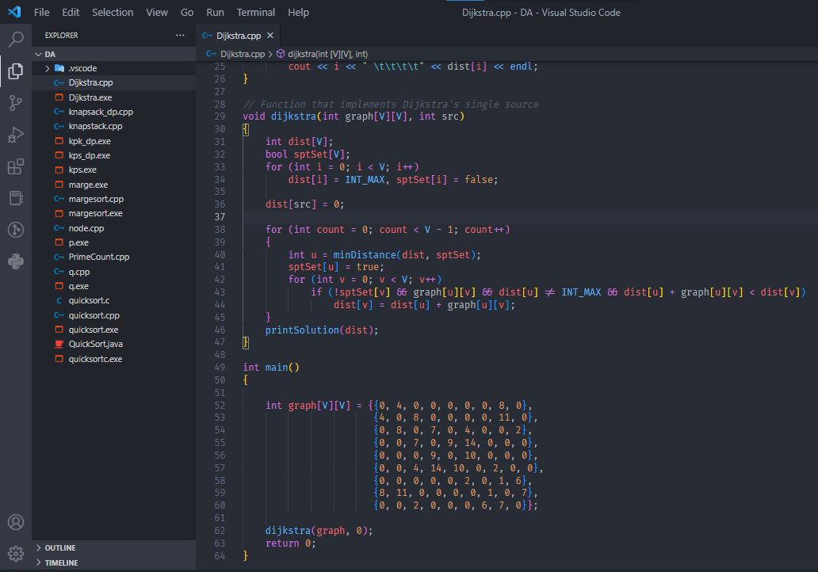

**Output (screenshots)**

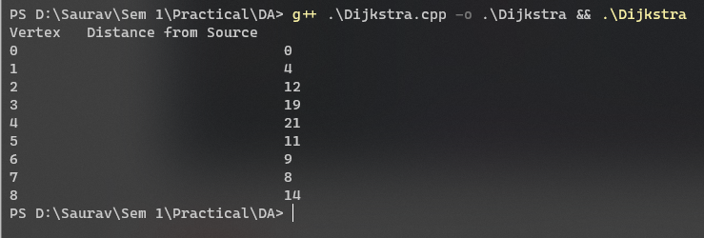

**Learning outcomes (What I have learnt): Times new roman 12 size**

**Evaluation Grid:**

|  |  |  |  |
| --- | --- | --- | --- |
| Sr. No. | Parameters | Marks Obtained | Maximum Marks |
| 1. | Demonstration and Performance  (Quiz) |  | 22 |
| 2. | Worksheet |  | 8 |